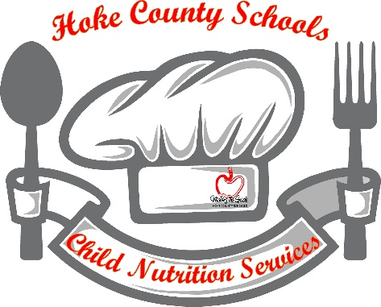

Hoke County Schools Public Notice

ALL STUDENTS ENROLLED IN HOKE COUNTY SCHOOLS WILL RECEIVE REIMBURSABLE MEALS AT “NO CHARGE” FOR THE 2023-2024 SCHOOL YEAR.

All Schools within Hoke County Schools District will once again participate in the USDA federally funded program, Community Eligibility Provision (CEP) for the 2023-2024 school year.
All students enrolled in Hoke County Schools will received their reimbursable breakfast and lunch meal at “NO CHARGE”. The Hoke County Schools Child Nutrition Program in conjunction with Hoke County Schools will not distribute and accept Free & Reduced Priced Meal Applications for the 2023-2024 School Year.

Any questions, please contact:
Deborah Davis Carpenter, Child Nutrition Executive Director,
Hoke County Board of Education, 310 Wooley Street, Raeford, NC, 28376.
Phone: (910) 875-4106

“Children must be healthy to learn and they must learn to be healthy”

Hoke County Schools Child Nutrition Services is honored to be a part of the National School Breakfast, School Lunch and Afterschool Snack Programs. We are proud to offer our students the nutrition they need to succeed. While adhering to the guidelines set forth by the United States Department of Agriculture (USDA), a variety of nutritious, delicious meals are offered to students each day for breakfast and lunch. Students cannot learn if they are hungry.
Free and Reduced Priced Meal Applications will not be accepted and processed for the 2023-2024 school year. All students enrolled in the Hoke County Schools district will receive their reimbursable breakfast and lunch meal at “NO CHARGE”. Therefore, there is no need to administer Free and Reduced Priced Meal Applications.
Thanks to the Federally Funded Program called CEP, all students attending CEP Schools (listed below) will receive their reimbursable breakfast and lunch meal at “NO CHARGE” for the 2023-2024 school year.

CEP schools are:
Don Steed Elementary
Hawk Eye Elementary
JW McLauchlin Elementary
Rockfish Hoke Elementary
Sandy Grove Elementary
Scurlock Elementary
West Hoke Elementary
Upchurch Elementary
East Hoke Middle
Sandy Grove Middle
West Hoke Middle
Hoke High
Turlington School
Sand Hoke Early College High

Hoke County Schools Child Nutrition Services looks forward to serving all students this school year to aid in their academic success. “Students must be healthy to learn, and they must learn to be healthy!”

If you have any questions regarding CEP Schools, please contact Deborah Davis Carpenter, Child Nutrition Executive Director and the Child Nutrition Services Team at 910.875.4106.

USDA Non-Discrimination Statement
In accordance with Federal civil rights law and U.S. Department of Agriculture (USDA) civil rights regulations and policies, the USDA, its Agencies, offices, and employees, and institutions participating in or administering USDA programs are prohibited from discriminating based on race, color, national origin, sex, disability, age, or reprisal or retaliation for prior civil rights activity in any program or activity conducted or funded by USDA.
Persons with disabilities who require alternative means of communication for program information (e.g. Braille, large print, audiotape, American Sign Language, etc.), should contact the Agency (State or local) where they applied for benefits. Individuals who are deaf, hard of hearing or have speech disabilities may contact USDA through the Federal Relay Service at (800) 877-8339. Additionally, program information may be made available in languages other than English.
To file a program complaint of discrimination, complete the USDA Program Discrimination Complaint Form, (AD-3027) found online at: http://www.ascr.usda.gov/complaint_filing_cust.html, and at any USDA office, or write a letter addressed to USDA and provide in the letter all of the information requested in the form. To request a copy of the complaint form, call (866) 632-9992. Submit your completed form or letter to USDA by:
(1) mail: U.S. Department of Agriculture
Office of the Assistant Secretary for Civil Rights
1400 Independence Avenue, SW
Washington, D.C. 20250-9410;
(2) fax: (202) 690-7442; or
(3) email: program.intake@usda.gov.
Hoke County Schools is an equal opportunity provider

